 | 
COUNCIL ASSESSMENT REPORT
HUNTER AND CENTRAL COAST REGIONAL PLANNING PANEL

PANEL REFERENCE & DA NUMBER | PPSHCC-405  DA 259/2025
PROPOSAL | 5Mw Battery Energy Storage System
ADDRESS | Lot 2 DP211171 and Lot 30 DP1113705 – 2243 Stroud Hill Road, Alison
APPLICANT | G8 Energy Pty Ltd
OWNER | L.R. and J.B. Ryan
DA LODGEMENT DATE | 16 December 2025
APPLICATION TYPE | Development Application – Regionally Significant
REGIONALLY SIGNIFICANT CRITERIA | Section 2.19(1) and Clause 5 of Schedule 6 of State Environmental Planning Policy (Planning Systems) 2021 declares the proposal regionally significant development as private infrastructure with a CIV over $5 million.
CIV | $5,700,406.00 (excluding GST)
CLAUSE 4.6 REQUESTS | Not applicable.
KEY SEPP/LEP | State Environmental Planning Policy (Planning Systems) 2021  State Environmental Planning Policy (Transport and Infrastructure) 2021  State Environmental Planning Policy (Biodiversity and Conservation) 2021  State Environmental Planning Panel (Resilience & Hazards) 2021  Dungog Local Environmental Plan 2014
TOTAL & UNIQUE SUBMISSIONS KEY ISSUES IN SUBMISSIONS | Seven (one letter of support and six letters objecting)
DOCUMENTS SUBMITTED FOR CONSIDERATION | Attachment A: Recommended Conditions of Consent  Attachment B: Development Plans  Attachment C: Visual Impact Assessment  Attachment D: Flood Risk Management Report (6/8/2026)  Attachment E: Transport Impact Statement
SPECIAL INFRASTRUCTURE CONTRIBUTIONS (S7.24) | Not applicable.
RECOMMENDATION | Conditional approval.
DRAFT CONDITIONS TO APPLICANT | No
SCHEDULED MEETING DATE | 15 September 2026
PLAN VERSION | Issue F. dated 11/06/2026
PREPARED BY | Philip Carroll – DSC Senior Development Planner
DATE OF REPORT | 7 September 2026

EXECUTIVE SUMMARY
The development application (DA259/2025) seeks consent for electricity generating works specifically involving the installation of a Battery Energy Storage System (BESS) and associated site works. The proposed BESS is a 5 Megawatt (MW) storage system that will be connected to the local electrical distribution network.
The application is referred to the Hunter Central Coast Regional Planning Panel as under Section 2.19(1) and Clause 5 of Schedule 6 of State Environmental Planning Policy (Planning Systems) 2021 the development is regionally significant development as it is private infrastructure with a CIV of over $5 million.
The site is legally identified as Lot 2 DP211171 and Lot 30 DP1113705 – 2243 Stroud Hill Road, Alison. The site is irregular in shape with the Williams River forming its western boundary and the North Coast Railway corridor effectively cutting it in two.
The subject area of the site where the development is proposed is approximately 2.4kms from Dungog and is located in a rural setting consisting of paddocks for livestock grazing. An Essential Energy electricity substation is in close proximity to the proposed location for the development.
The principal planning controls relevant to the assessment are State Environmental Planning Policy (Planning Systems) 2021, State Environmental Planning Policy (Transport and Infrastructure) 2021, State Environmental Planning Policy (Biodiversity and Conservation) 2021, State Environmental Planning Policy (Resilience and Hazards) 2021 and Dungog Local Environmental Plan 2014.

Pursuant to Dungog Local Environmental Plan 2014, the site is Zone RU1-Primary Production. The proposed development is characterised as electricity generating works which is prohibited in the zone. The permissibility pathway used for this application falls under Section 2.36(1) of State Environmental Planning Policy (Transport and Infrastructure) 2021 where electricity generating works is permissible in the prescribed rural zone with consent.

Delays were experienced in the assessment of the application as amendments to the design were required, namely in regards to access arrangements, which were initially through the adjoining Essential Energy site.

The application was placed on public exhibition from 24 December 2025 to 29 January 2026 with no submissions received. The application was amended by the proponent and renotified from 29 April 2026 to 13 May 2026 with seven submissions being received (one letter of support and six objections). The submissions were brief and raised issues relating to not wanting the development in the area, land values, visual impact, and impacts on farming and waterways. These issues are considered further in this report.

Based on the site being located within a drinking water catchment, the key issues associated with the proposed development are flooding and water quality. These issues have been resolved through recommended conditions of consent.

The proposed development has been assessed against the applicable planning controls and is considered satisfactory. It represents part of the transition of the electricity network with the aim of reducing environmental impacts whilst retaining reliable supply. Approval of the development is therefore considered to be in the public interest.

Following consideration of the matters under Section 4.15(1) of the EP&A Act, the proposed development is considered acceptable and is recommended for approval.

- THE SITE AND LOCALITY

  - The Site

The site is legally described as Lot 2 DP211171 and Lot 30 DP1113705 – 2243 Stroud Hill Road, Alison. The site is irregular in shape with the Williams River forming its western boundary and the North Coast Railway corridor effectively cutting it in two.
The site is in a rural setting, consisting of expansive paddocks used for the grazing of cattle. The land has been largely cleared of native vegetation, is undulating towards the north and east (gentle hills), and is relatively flat towards the south and west.

The site is located within the Williams River Drinking Water Catchment and is mapped as flood prone. The area where the development is proposed to be located is located outside the 1% AEP area, although is mapped as being with the PMF.

The site is affected by bushfire; however, this constraint is not considered to cause it to be unsuitable for the proposed development.

The subject area of the site where the development is proposed is approximately 2.4kms from Dungog. An Essential Energy electricity substation affectively adjoins this area.

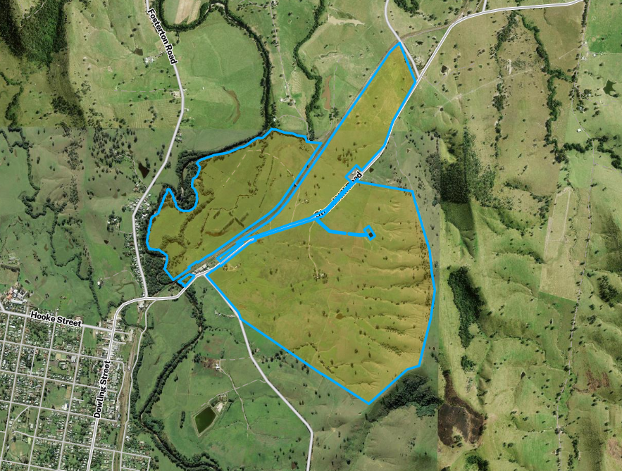

Figure 1: Aerial photo of the site and immediate surrounds (Explorer 4/9/2026)

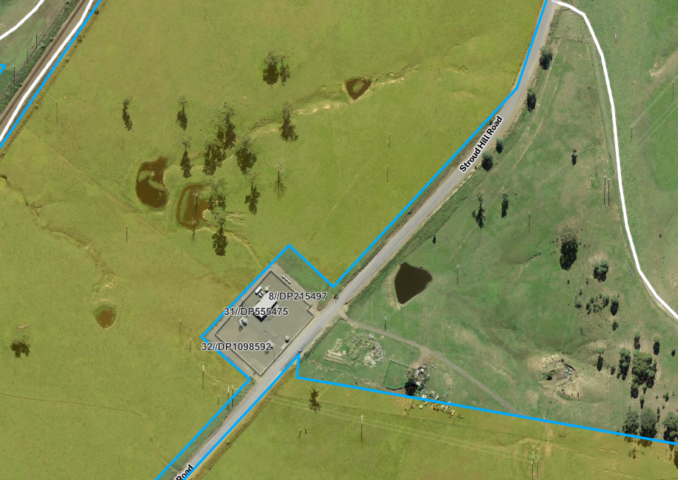

Figure 2: Zoomed in aerial photo showing the area where the development is proposed - just north of the electricity substation (Explorer 4/9/2026)
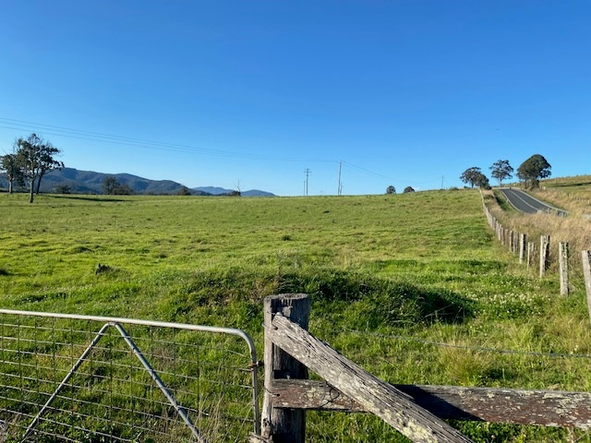

Figure 3: View of the location where the development is proposed looking north

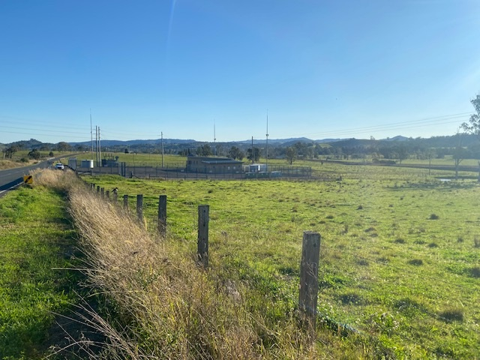

Figure 4: View of the location where the development is proposed looking south
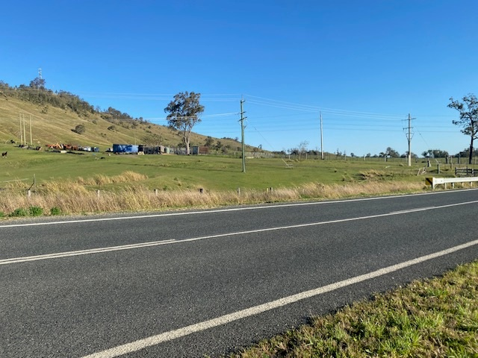

Figure 5: View of the land located opposite looking east

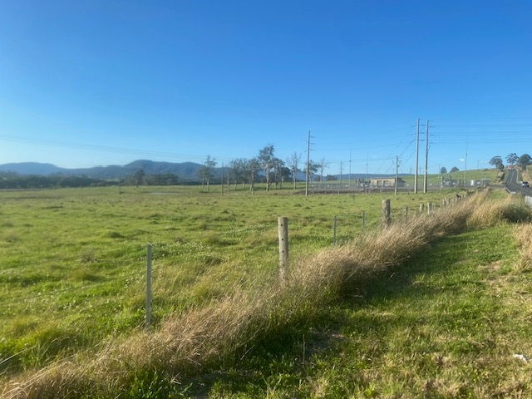

Figure 6: View of the site looking north with the electricity substation in the background

  - The Locality

The locality is rural in character, consisting of large expansive open areas used for agricultural pursuits such as the grazing of cattle. The land has been largely cleared of native vegetation, is undulating towards the north and east (hills), and relatively flat towards the south and west which is identified as flood prone.

Dwellings and farm buildings are scattered throughout but are not a prominent element of the landscape. Lot sizes and shapes are varied with no consistent pattern.

Stroud Hill Road forms the site’s eastern frontage which connects Dungog with Stroud to the east via The Buckets Way. The North Coast Rail corridor also runs through the area forming a physical boundary between its east and west. A small electricity substation controlled by Essential Energy is located in close proximity to the development site and has a visual presence.

- THE PROPOSAL AND BACKGROUND

  - The Proposal

The application’s Statement of Environmental Effects (p6) describes the proposed development in the following:

Specially, the proposed development includes:-

- Road-based gravel access driveway
- Four (4) BESS modular units
- One (1) Power Conversion System (PCS) modular unit
- Four (4) EIP units
- Two (2) LC units
- Perimeter high-security (Man-proof) fencing
- Creation of vehicle access via Lot 30 DP1113705

No demolition or tree removal is required.

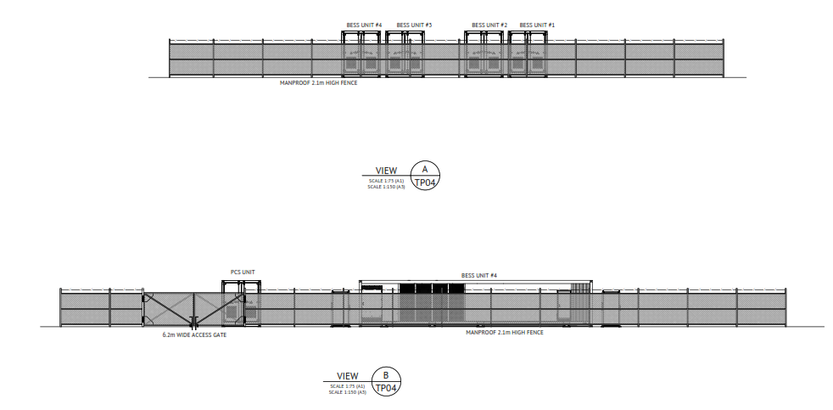
Figure 7: Elevation Plan
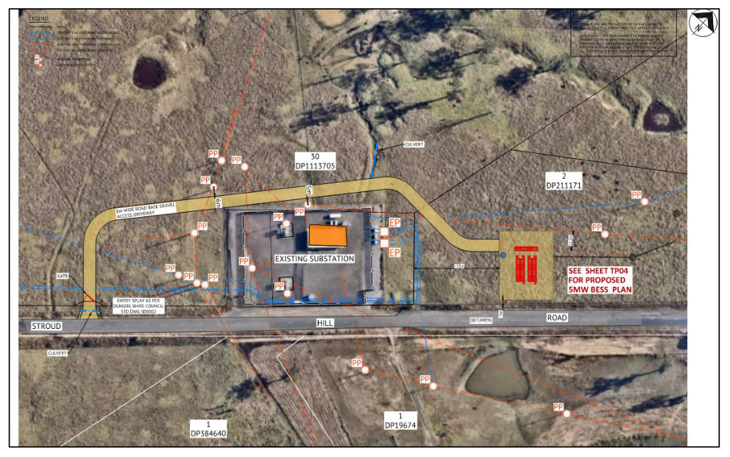
Figure 8: Plan showing the subject area where the development is proposed

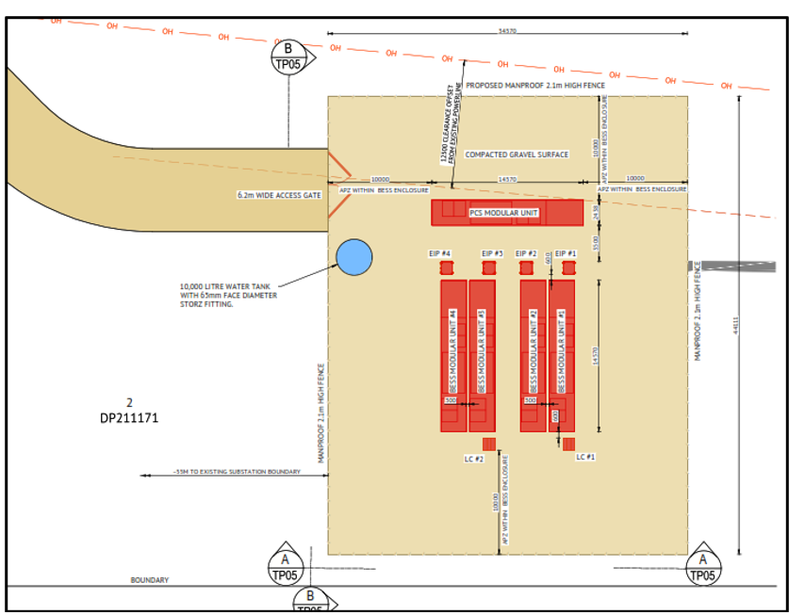

Figure 9: Zoomed in plan showing the BESS pad and a section of the access road

  - Background

A pre-lodgement meeting was held prior with the applicant and their consultants on 10 October 2025. Based on the original design (where access was via the Essential Energy site) the meeting was positive with the main issues discussed being:

- the approval pathway;
- potential for objections;
- information requirements; and,
- consideration of a Council culvert which runs under Stroud Hill Road and discharges in proximity of the pad (raised in subsequent notes from the meeting).
The development application was lodged on 16 December 2025. A chronology of the development application since lodgement is outlined below including the Panel’s involvement (briefings, deferrals etc) with the application:

Table 2: Chronology of the DA
Date | Event
16 December 2025 | DA lodged
24 December 2025 | First exhibition of the application  24/12/2025 until 29/1/2026
24 December 2025 | DA referred to external agencies
23 February 2026 | Request for Information from Council to applicant
30 March 2026 | Request for Information from Council to applicant
25 May 2026 | Request for Information from Council to applicant – respond to submissions
8 July 2026 | Request for Information from Council to applicant
NA | Panel briefing – Not undertaken.
6 August 2026 | Amended plans and documents lodged with a revised site plan for the internal road and flood information.

  - Site History
An approval to subdivide four lots into six lots (DA139/2020) consisting of Lot 1 DP384640, Lot 2 DP211171, Lot 26 DP1112248 and Lot 30 DP1113705 was granted by Council on 6 September 2021. The approved subdivision will not conflict with the proposed siting of the BESS development.

- STATUTORY CONSIDERATIONS
When determining a development application, the consent authority must take into consideration the matters outlined in Section 4.15(1) of the Environmental Planning and Assessment Act 1979 (‘EP&A Act’). These matters as are of relevance to the development application include the following:

- the provisions of any environmental planning instrument, proposed instrument, development control plan, planning agreement and the regulations
(i) any environmental planning instrument, and
(ii) any proposed instrument that is or has been the subject of public consultation under this Act and that has been notified to the consent authority (unless the Planning Secretary has notified the consent authority that the making of the proposed instrument has been deferred indefinitely or has not been approved), and
(iii) any development control plan, and
(iiia) any planning agreement that has been entered into under section 7.4, or any draft planning agreement that a developer has offered to enter into under section 7.4, and
(iv) the regulations (to the extent that they prescribe matters for the purposes of this paragraph),
that apply to the land to which the development application relates,
- the likely impacts of that development, including environmental impacts on both the natural and built environments, and social and economic impacts in the locality,
- the suitability of the site for the development,
- any submissions made in accordance with this Act or the regulations,
- the public interest.

These matters are further considered below.

It is noted that the proposal is not considered to be:

- Integrated Development (s4.46)
- Designated Development (s4.10)
- Requiring concurrence/referral (s4.13)
- Crown DA (s4.33) - written agreement from the Crown to the proposed conditions of consent must be provided

  - Environmental Planning Instruments, proposed instrument, development control plan, planning agreement and the regulations

The relevant environmental planning instruments, proposed instruments, development control plans, planning agreements and the matters for consideration under the Regulation are considered below.

- Section 4.15(1)(a)(i) - Provisions of Environmental Planning Instruments

The following Environmental Planning Instruments are relevant to this application:

- State Environmental Planning Policy (Biodiversity and Conservation) 2021
- State Environmental Planning Policy (Planning Systems) 2021
- SEPP (Resilience and Hazards) 2021
- State Environmental Planning Policy (Transport and Infrastructure) 2021
- Dungog Local Environmental Plan 2014

A summary of the key matters for consideration arising from these State Environmental Planning Policies are outlined in Table 3 and considered in more detail below.

Table 3: Summary of Applicable Environmental Planning Instruments

EPI | Matters for Consideration | Comply (Y/N)
State Environmental Planning Policy (Biodiversity & Conservation) 2021 | Chapter 3: Koala Habitat Protection 2020  Applies to the development pursuant to clause 3.3 and aims to encourage the property conservation and management of areas of natural vegetation that provide habitat for koalas to ensure a permanent free-living population over their present range and reverse the current trend of koala population decline. The development does not propose the removal of any trees nor impact on any known koala habitat. | Y
State Environmental Planning Policy (Planning Systems) 2021 | Chapter 2: State and Regional Development  Section 2.19(1) declares the proposal regionally significant development pursuant to Clause 5 of Schedule 6 of State Environmental Planning Policy (Planning Systems) 2021 as it is private infrastructure with a CIV over $5 million. | Y
SEPP (Resilience & Hazards) | Chapter 4: Remediation of Land  Section 4.6 – Potential contamination has been considered and the proposal is satisfactory. | Y
State Environmental Planning Policy (Transport and Infrastructure) 2021 | Chapter 2: Infrastructure  Section 2.36(1) (Development permitted with consent) – the application is using this as the permissibility pathway. | Y
Proposed Instruments | No new/amened planning instruments are triggered. | Y
Dungog LEP 2014 | Clause 2.3 – Permissibility and zone objectives  Prohibited in the RU1-Primary Production Zone. The application is using SEPP (Transport & Infrastructure) as its permissibility pathway.  Objects of the LEP and zone are considered satisfactory.  Drinking water catchment provisions can be achieved through conditions of consent. | Conditions imposed
DCP | Requirements relating to buffers in rural zones and biodiversity are satisfactory. The application does not fully comply with DCP requirements for flooding. Conditions have been imposed to address. | N  Conditions imposed

State Environmental Planning Policy (Biodiversity and Conservation) 2021

Chapter 3: Koala Habitat Protection 2020

Areas of the site are mapped as having biodiversity values, however the location where the development is proposed to take place is not identified as one of them.

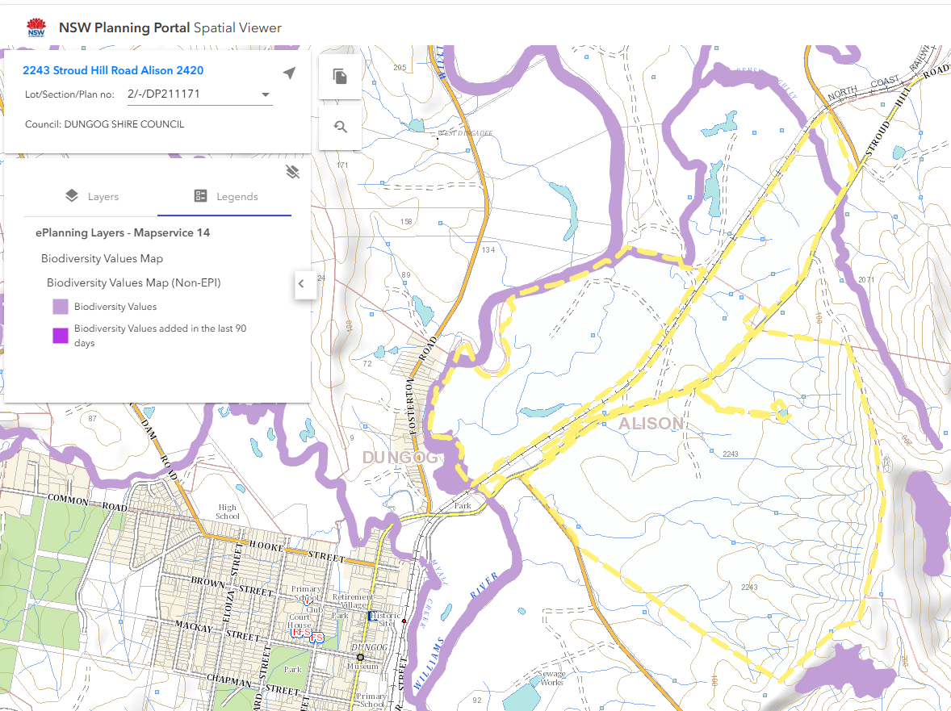

Figure 10: Biodiversity Values Map (Planning Portal Spatial 4/9/2026)

Chapter Three of the B&C SEPP applies to the development pursuant to clause 3.3 and aims to encourage the property conservation and management of areas of natural vegetation that provide habitat for koalas to ensure a permanent free-living population over their present range and reverse the current trend of koala population decline.

Table 4. Summary of Chapter Three Triggers

Question | Development | Outcome
Clause 3.5 – Does the site have a site area greater than 1.0ha or does the site form part of a landholding greater than 1.0ha in area? | Yes | Assessment under SEPP (B&C) required.

Clause 3.5 – Step 1  Is the land potential koala habitat?  NOTE: ‘potential koala habitat’ are areas of native vegetation where trees of the types listed in Schedule 2 of the SEPP (feed tree species) constitute at least 15% of the total number of trees in the upper or lower strata of the tree component. | No  Council must take the guidelines into consideration in determining an application for consent to carry out development on land to which this Part applies.  The Guidelines are contained in the Department of Planning Circular No B35 dated 22 March 1995. The Circular states in clause 1.5 “In relation to affected DAs it is the intention of the policy that investigations for ‘potential’ and ‘core’ koala habitats be limited to those areas in which it is proposed to disturb habitat”.  As no tree removal is proposed, there would be no disturbance to habitat, and the requirements of the SEPP are satisfied. | Development satisfactory under B&C SEPP.

State Environmental Planning Policy (Planning Systems) 2021

Chapter 2: State and Regional Development

The proposal is regionally significant development pursuant to Section 2.19(1) as it satisfies the criteria in Clause 5 of Schedule 6 of the Planning Systems SEPP, being development for private infrastructure with a CIV over $5 million. Accordingly, the Hunter Central Coast Regional Planning Panel is the consent authority for the application. The proposal is consistent with this Policy.

State Environmental Planning Policy (Resilience and Hazards) 2021

Chapter 4: Remediation of Land

The provisions of Chapter 4 of State Environmental Planning Policy (Resilience and Hazards) 2021 (‘the Resilience and Hazards SEPP’) have been considered in the assessment of the development application. Section 4.6 of Resilience and Hazards SEPP requires consent authorities to consider whether the land is contaminated, and if the land is contaminated, it is satisfied that the land is suitable in its contaminated state (or will be suitable, after remediation) for the purpose for which the development is proposed to be carried out.
The subject area of the site has historically been used for the grazing of livestock. It is unlikely that the land is contaminated given this use. The proposed development will infrequently be used (maintenance workers periodically) and does not pose a risk to human health. The proposal is therefore considered to be consistent with the requirements of the SEPP.

State Environmental Planning Policy (Transport and Infrastructure) 2021

The proposed development is permissible with consent under Clause 2.36(1) of SEPP (Infrastructure and Transport).

Dungog Local Environmental Plan 2014

The relevant local environmental plan applying to the site is the Dungog Local Environmental Plan 2014 (‘the LEP’). The aims of the LEP include:

(aa) to protect and promote the use and development of land for arts and cultural activity, including music and other performance arts,
(a) to protect rural lands, natural resources, and items and areas of heritage significance,
(b) to manage development to benefit the community,
(c) to promote the principles of ecologically sustainable development and sustainable water management, and to recognise the cumulative impacts of climate change,
(d) to protect, enhance and provide for biological diversity, including native threatened species, populations and ecological communities, by long term management and by identifying and protecting habitat corridors and links throughout Dungog,
(e) to encourage a mix of housing to meet the needs of the community,
(f) to protect agricultural lands by preventing adverse impacts from non-agricultural land uses,
(g) to strengthen retail, agricultural and tourism opportunities.

The proposed development is considered to be consistent with the aims of the Plan in terms of facilitating development which will be of benefit to the community as part of the transition to improved sustainable environmental outcomes within the electricity network, whilst ensuring that water quality within the catchment is maintained.

Zoning and Permissibility (Part 2)

The site is located within Zone RU1-Primary Production pursuant to Clause 2.2 of the LEP.

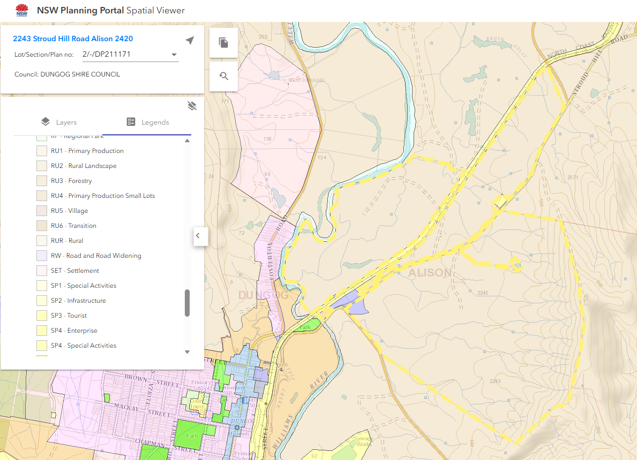

Figure 11: LEP Zone Map (Planning Portal Spatial 4/9/2026)

Pursuant to the LEP, the proposed development is characterised as electricity generating works which is not listed as a permissible use in the zone in the Land Use Table in Clause 2.3 and is therefore prohibited under the LEP. The proposed development is however permissible with consent under Clause 2.36(1) of SEPP (Infrastructure and Transport).

The zone objectives include the following (pursuant to the Land Use Table in Clause 2.3):

- To encourage sustainable primary industry production by maintaining and enhancing the natural resource base.
- To encourage diversity in primary industry enterprises and systems appropriate for the area.
- To minimise the fragmentation and alienation of resource lands.
- To minimise conflict between land uses within this zone and land uses within adjoining zones.
- To provide for recreational and tourist activities that are compatible with the agricultural, environmental and conservation value of the land.
- To promote the rural amenity and scenic landscape values of the area and prevent the silhouetting of unsympathetic development on ridgelines.

The proposed development is considered to be consistent with the objectives of the zone in terms of having regard in its siting to minimise fragmentation of resource lands, and by having minimal conflict with other uses in the zone, namely agriculture.

General Controls and Development Standards (Part 2, 4, 5 and 6)

The LEP also contains matters relating to local provisions. The clauses relevant to the proposal are considered in Table 5 below.

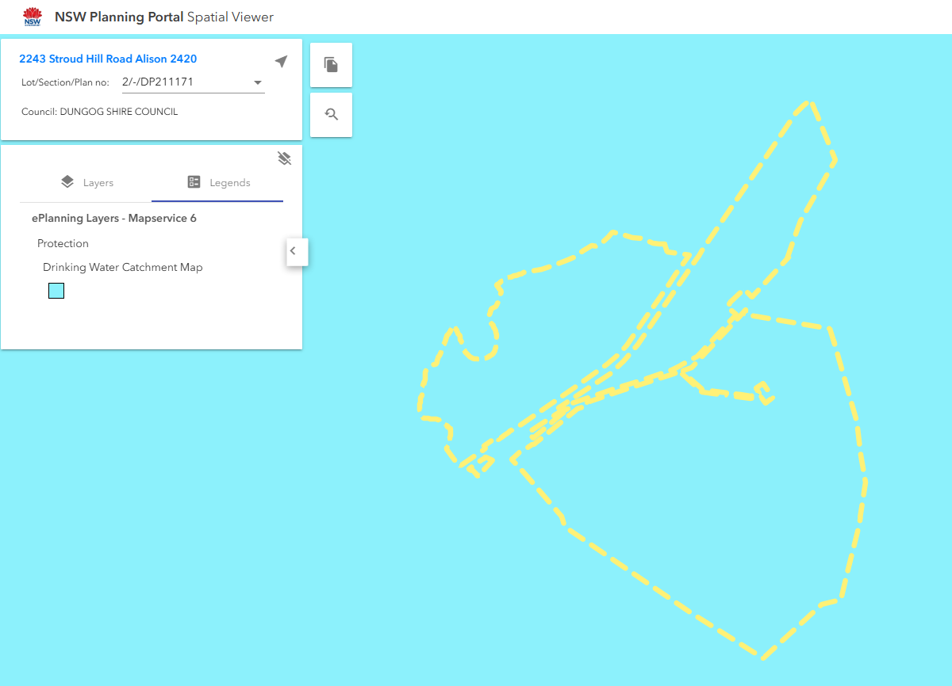

Figure 12: Drinking Water Catchment Map (Planning Portal Spatial 4/9/2026)

Table 4: Consideration of the LEP Controls
Control | Requirement | Proposal | Comply
5.21 Flood Planning | Consideration is to be given to flooding in terms of function and behaviour, risk to life and impacts on other properties. | The siting of the proposed development is outside the 1% AEP mapped flood area. Information submitted by the applicant requires refinement. Impacts associated with a PMF event are addressed through appropriate conditions. | Conditions imposed to address.
6.5 Drinking Water Catchment | Consideration is to be given to the distance between the development and any waterway, on-site chemicals, treatment, storage and disposal of waste water. | Information submitted by the applicant requires refinement. Impacts associated with water quality are addressed through appropriate conditions. | Conditions imposed to address.
6.10 Williams River Catchment | Consideration is to be given to the promotion of the sustainable use of land and water, the protection and improvement of the catchment’s environmental qualities, and any significant adverse impacts on water quality. | Information submitted by the applicant requires refinement. Impacts associated with water quality are addressed through appropriate conditions. | Conditions imposed to address.

With appropriate conditions, the development will achieve compliance with Clause 5.21(1), Clause 6.5 and Clause 6.10.

- Section 4.15 (1)(a)(ii) - Provisions of any Proposed Instruments

There are no proposed instruments which have been the subject of public consultation under the EP&A Act.

- Section 4.15(1)(a)(iii) - Provisions of any Development Control Plan

The following Development Control Plan is relevant to this application:

Dungog Development Control Plan No. 1 (‘the DCP’)

C7. Buffer Zones
The proposed development is sited in a suitable area to minimise any potential land use conflicts within the locality, namely agriculture. Distances from adjoining boundaries is considered appropriate. Its location in proximity to Stroud Hill Road is satisfactory.

C8. Managing Our Flood Plains
The application does not achieve full compliance with Council’s DCP Chapter C8 – Managing Our Flood Plains. The development has not addressed the specific requirements of Schedule 2 – Floodplain Areas Planning Matrix Controls – Flood Affection. It is considered that appropriate conditions can be imposed to adequately address this issue.

C9. Biodiversity
Areas of the site are identified as containing biodiversity values, however the location where the development is proposed is not. No clearing of trees is proposed. The development will not have an adverse impact on biodiversity.

Development Contributions

The following contributions plans are relevant pursuant to Section 7.18 of the EP&A Act and have been considered in the recommended conditions (notwithstanding Contributions plans are not DCPs they are required to be considered):

- Dungog Local Infrastructure Development Contributions Plan (2019)

Under the Plan the payment of Section 7.12 developer contributions is triggered. Appropriate conditions have been included in the recommended conditions requiring payment.

- Section 4.15(1)(a)(iiia) – Planning agreements under Section 7.4 of the EP&A Act

There have been no planning agreements entered into and there are no draft planning agreements being proposed for the site.

- Section 4.15(1)(a)(iv) - Provisions of Regulations

The application does not trigger any matters for consideration under section 61 of the Environmental Planning and Assessment Regulation 2021.
  - Section 4.15(1)(b) - Likely Impacts of Development

The main likely impacts of the development relate to traffic, flooding and visual impact as addressed below.

Traffic
The proposed development will create a new access point onto Stroud Hill Road. Stroud Hill Road at this location is a Council maintained public road. At the site of the proposed development, Stroud Hill Road has a carriageway width of approximately 8m, a sealed surface treatment 7m wide and gravel / grassed shoulders / table drains.
The Traffic Impact Statement (TIS) prepared by Premise (Rev C) utiliised traffic count data from the TfNSW Traffic Volume Viewer near to the subject site. The TfNSW data indicated that traffic volumes in the vicinity of the site were in the order of 1238 vehicles per day (VPD) in 2007. The TIS did not however update this figure to a present-day estimate utilising an assumed background growth rate. Assuming an annual growth rate of 1.5 to 2%, present-day volumes would likely be in the order of 1650 to 1800 vpd or approximately 165 to 180 vehicle trips per hour (vph). This equates to approximately 80 to 90 vehicles in each direction on Stroud Hill Road.
Construction traffic is assessed in detail by the TIS; over the 12-week construction period, traffic generation is estimated as 100 vpd during peak construction periods. The traffic will be generated by an estimated 15 construction employees and 30 heavy vehicles. The TIS suggests that as construction progresses, employee numbers could drop to approximately 4. Similarly, it is expected that heavy vehicle movements would lessen significantly as bulk earthworks and material deliveries are completed. The short-term traffic impacts associated will construction will be managed through the implementation of traffic management plans, traffic guidance schemes, temporary speed reduction and appropriate advisory signage / delineation. Conditions have been included below requiring Council’s approval of these measures in conjunction with the S138 Roads Act approval. A condition requiring a detailed construction management plan has also been included.
The TIS notes that the development will only generate very minimal traffic once completed. Estimated daily traffic flows vary from 2 to 4 vpd for scheduled and unscheduled maintenance respectively. Scheduled maintenance is only forecast to occur every one to two months.
The TIS has assessed the proposed new access location from a sight distance perspective and found that compliance with AUSTROADS safe intersection sight distance (SISD) is achievable. The assessment included both a desktop and on-site confirmation that SISD is achievable.

The proposed new access off Stroud Hill Road will require construction in accordance with Council’s Standard Drawing SD002 to provide a bitumen sealed connection to the site and sufficient setback distances for a vehicle to enter the site without impacting upon traffic flows with Stroud Hill Road. A condition has been included requiring the construction of the new access to Council’s standards.
Given the low traffic volumes on Stroud Hill Road and the minor nature of the ongoing traffic generated by the development post-construction, it is considered that the proposed traffic management during construction along with completion of the new access crossing, will suitably address any potential traffic impacts.

Flooding
Council does not hold detailed flooding information covering the subject site; as such, a site-specific flood study has been completed in conjunction with the development application. The site is transected by a number of existing watercourses, as identified Figure 4 below.

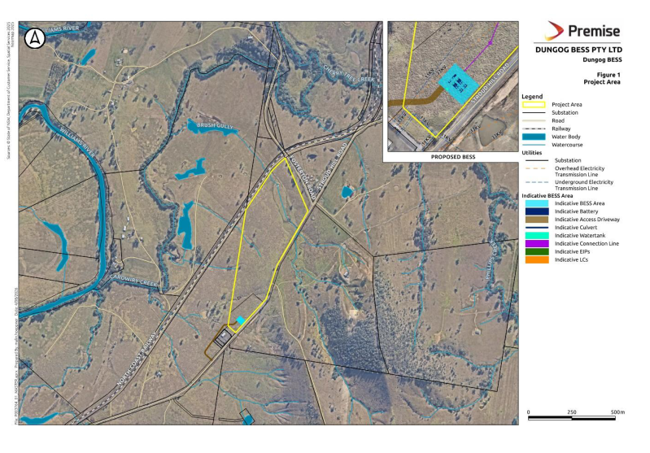
Figure 13: Subject site existing watercourses

A Flood Impact Assessment (FIA) has been submitted as part of the application and was prepared by Premise (Revision D – 4 August 2026), in support of the application. The proposed development layout and the modelled extent of 1% AEP flooding is shown below in Figure 14.

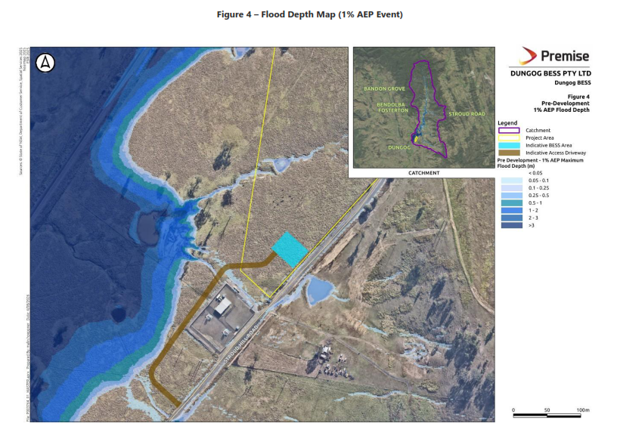
Figure 14: Design Flood Extents (1%AEP)

The design flood extent for the PMF event is shown in Figure 15 below:

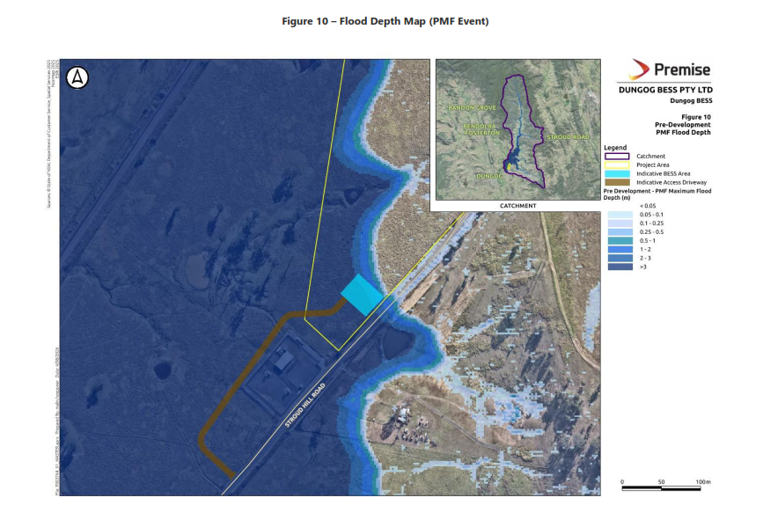
Figure 15: Design Flood Extents (PMF)
As shown in Figure 14, the site of the proposed development and the access road / earthworks are both clear of the 1% AEP flood extent. However, both the access road and the battery facility are fully inundated during the PMF event as shown by Figure 15.

Given the location of the proposed access road, earthworks and battery facility and its proximity to the existing Essential Energy substation, the proposed development must not result in any potential flood impact upon the substation. As such, the civil plans must demonstrate no increase in ground height in the vicinity of any Essential Energy infrastructure and the use of non-conductive materials. Cconditions of consent are recommended in this regard.

Visual Impact
The proposed development is to be sited on land which adjoins an existing Essential Energy substation. The size and area used for the proposed development will be smaller than the existing substation. Visually, the two developments will read as separate (based on fencing), however by grouping them together this impact will be reduced.

Accordingly, it is considered that the proposal will not result in any significant adverse impacts in the locality.

  - Section 4.15(1)(c) - Suitability of the site

The locality is rural in character, consisting of large expansive open areas used for agricultural pursuits such as the grazing of cattle. The land has been largely cleared of native vegetation, is undulating towards the north and east (hills), and relatively flat towards the south and west which is identified as flood prone. It is noted that the area where the development is to be sited is not mapped as being in the 1% AEP flood extent although is mapped as being affected by the PMF. To address this issue and progress the determination of the application, conditions have been imposed.

Vehicle access/egress into the site is adequate from a sight distance perspective.

The area of the site where the development is proposed has a gentle rise and as such cut and fill will be required to create the pad and internal road. The extent of work involved is not considered excessive with impacts manageable.

No sensitive vegetation is proposed to be removed. Whilst the land is mapped as bushfire prone, this is not an issue which prevents the development from taking place.

Given the extent of open space surrounding the development site impacts on agricultural uses will be minimal. Conditions have been recommended to achieve appropriate water quality outcomes.

Given the above, the site is considered suitable for the proposed development.

  - Section 4.15(1)(d) - Public Submissions

These submissions are considered in Section 5 of this report.

  - Section 4.15(1)(e) - Public interest

The proposed development has been assessed against the applicable planning controls and is considered satisfactory. It represents part of the transition of the electricity network with the aim of reducing environmental impacts whilst retaining reliable supply. Approval of the development is therefore considered to be in the public interest.

- REFERRALS AND SUBMISSIONS

  - Agency Referrals and Concurrence

The development application has been referred to various agencies for comment/concurrence/referral as required by the EP&A Act and outlined below in Table 5.

The outstanding issues raised by Hunter Water and Essential Energy are addressed in the Key Issues section of this report.

Table 5: Concurrence and Referrals to agencies
Agency | Concurrence/  referral trigger | Comments  (Issue, resolution, conditions) | Resolved
Concurrence Requirements (s4.13 of EP&A Act)
Environment Agency Head (Environment, Energy & Science Group within DPIE) | S7.12(2) - Biodiversity Conservation Act 2016 |  | NA
Rail authority for the rail corridor | Section 2.98(3) - State Environmental Planning Policy (Transport and Infrastructure) 2021 |  | NA
Referral/Consultation Agencies
RFS | S4.14 – EP&A Act  Development on bushfire prone land |  | NA
Electricity supply authority | Section 2.48 – State Environmental Planning Policy (Transport and Infrastructure) 2021  Development near electrical infrastructure | The application was referred to Essential Energy who initially objected to the use of their property for access/egress to the development site.  The developer made changes to resolve this issue however the revised internal road location encroached into the flood effected area of the site which presented further issues.  The developer again revised the location of the internal driveway with it now running within proximity to the southern and western boundaries of the substation site.  An application to undertake works within a zone of influence was made by the developer and approved by Essential Energy dated 20 August 2026. | Yes
Rail authority | Section 2.97 – State Environmental Planning Policy (Transport and Infrastructure) 2021  Development land that is in or adjacent to a rail corridor. | Given the proximity of the North Coast Rail line to the site, the application was referred to ARTC for consideration. ARTC did not provide comments. | Yes
Transport for NSW | Section 2.121 – State Environmental Planning Policy (Transport and Infrastructure) 2021  Development that is deemed to be traffic generating development in Schedule 3. |  | NA
Design Review Panel | Cl 28(2)(a) – SEPP 65  Advice of the Design Review Panel (‘DRP’) |  | NA
Hunter Water | S51(2) of the Hunter Water Act 1991  Referral of a development application on land located in a drinking water catchment area.  Council to take into account any submission made in determining whether to consent to the application or to attach conditions. | The site is located within the Williams River Drinking Water Catchment Area. The application was referred to Hunter Water for consideration.  Hunter Water in correspondence dated 10 August 2026 advised that conditions could be employed to address the use of VENM for imported materials, however the information submitted by the applicant did still not satisfy the requirements of NorBE.  The issues raised have been considered by Council in the assessment of the application and resolved through conditions of consent. | Yes
Fire & Rescue |  | Given the potential risks associated with the development, the application was referred to NSW Fire & Rescue for consideration who advised that no specific guidance or requirements are currently in place for smaller scale BESS projects, outside what is required by applicable legislation or standards. Advice will be included into the development consent recommending reference is made to other guidelines for larger projects. | Yes
Integrated Development (S 4.46 of the EP&A Act)
RFS | S100B - Rural Fires Act 1997  bush fire safety of subdivision of land that could lawfully be used for residential or rural residential purposes or development of land for special fire protection purposes |  | NA
Natural Resources Access Regulator | S89-91 – Water Management Act 2000  water use approval, water management work approval or activity approval under Part 3 of Chapter 3 |  | NA

  - Council Officer Referrals

The development application has been referred to the following Council officers for technical review as outlined Table 7.

Table 7: Consideration of Council Referrals
Officer | Comments | Resolved
Engineering | Council’s Development Engineer provided conditions to resolve issues associated with flooding and stormwater management. | Yes
Traffic | Council’s Development Engineer assessed the application and confirmed that traffic volumes generated by the development during construction and once operational are acceptable given the existing capacity of the road network, and that sightlines are compliant with AUSTROADS safe intersection sight distances (SISD). Recommended conditions requiring works within the road reserve to service the site have been imposed as part of the development consent (e.g. a s138 Roads Act 1993 approval is in place, and the works are completed to the satisfaction of Council). | Yes
Building |  | NA
Health & Environment | Recommended conditions requiring appropriate environmental management practices to be in place have been imposed as part of the development consent (e.g. sediment and erosion control, noise, dust, disposal of surplus fill and import of clean fill etc.). | Yes
Waste |  | NA
Public Domain/  Assets |  | NA
Heritage |  | NA

The outstanding issues raised by Council officers are considered in the Key Issues section of this report.
  - Community Consultation

The development application was initially notified in accordance with the Council’s Community Participation Plan from the 24 December 2025 until 27 January 2026 (due to complications with the Planning Portal the exhibition period was extended to 29 January 2026). The notification included the following:

- Notification letters sent to adjoining and adjacent properties (five letters in total were sent);
- Notification on Council’s website; and,
- Notification to elected councillors.

One submission was received from Essential Energy objecting to the use of their site for vehicle access/egress arrangements.

Subsequently, the design of the development was amended by the proponent to the extent that Council considered the application required re-notification (the driveway servicing the site was changed). Re-notification took place from 29 April 2026 to 13 May 2026. The notification included the following:

- Notification letters sent to adjoining and adjacent properties (five letters in total were sent);
- Notification on Council’s website; and,
- Notification to elected councillors.

Seven unique submissions, comprising of six objections and one letter of support were received. In this instance Essential Energy did not make a submission. The submissions were brief with the issues raised considered in Table 8.

Table 8: Community Submissions
Issue | No of submissions | Council Comments
Will drop land values. | 1 | Property values are not a planning consideration.
We don’t want this in our town. | 4 | The development largely satisfies the applicable planning controls and has been assessed as suitable given the qualities of the site and its potential impacts.
Will impact farms and waterways in the area. | 3 | The footprint of the development is small in context with its surrounds and its potential impacts considered minor and acceptable. Appropriate conditions are in place to protect water quality.
Located in a floodway. | 1 | The design of the development has since been amended and is no longer located within the 1% AEP flood affected area and is not located within a floodway.
Visual impact. | 1 | It is acknowledged that the development will change the area’s landscape. The siting of the development is in close proximity to an existing substation and has a small footprint in the context of the locality. The scale and appearance of the development is not considered bulky nor intrusive and is acceptable.
Will keep the lights on in the district. | 1 | Letter of support noted.

- KEY ISSUES
The following key issues are relevant to the assessment of this application having considered comments by Hunter Water and Essential Energy.
5.1 Hunter Water

The application does not include any draft civil engineering plans or a stormwater and water quality report.

Hunter Water in their correspondence dated 10 August 2026, requested the following:

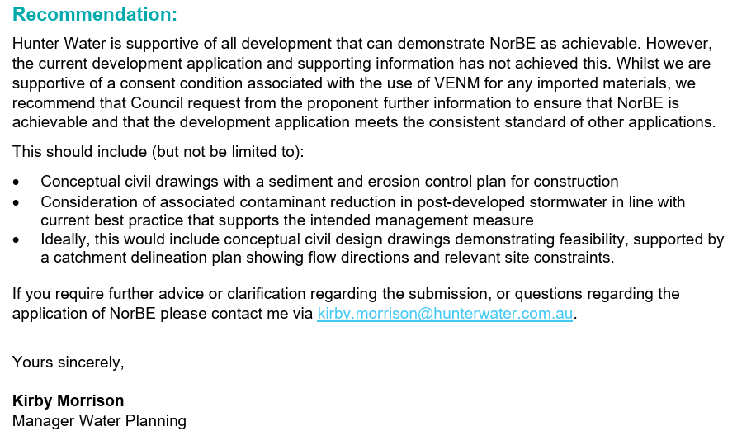

To resolve this issue engineering conditions have been formulated to address the matters listed above. Engineering conditions requiring amended plans prior to the issue of any Construction Certificate (CC) as well as additional information at CC stage are recommended.

5.2 Essential Energy

Essential Energy in their correspondence dated 20 August 2026, requested the following:

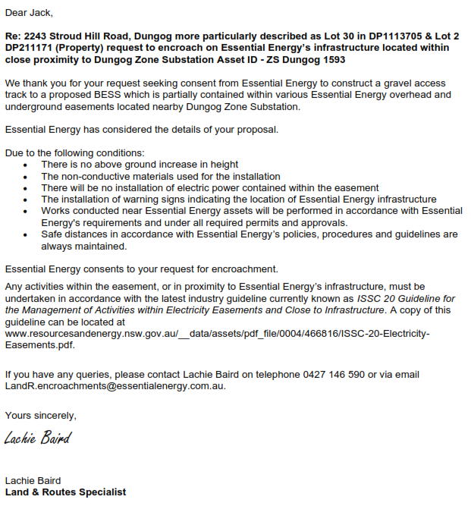

Engineering conditions have been formulated to address this matter. Engineering conditions requiring amended plans prior to the issue of any Construction Certificate (CC) as well as additional information at CC and “During Construction” stages are recommended.

- CONCLUSION

This development application has been considered in accordance with the requirements of the EP&A Act and the Regulations as outlined in this report. Following an assessment of the relevant planning controls, issues raised in submissions and the key issues identified in this report, it is considered that the application can be supported.

The development’s visual impact is considered acceptable. The road network is capable of managing any additional traffic and sightlines are satisfactory. Appropriate conditions have been imposed to address comments raised by Hunter Water and Essential Energy.

Given the location where the development is proposed, the site is considered suitable and appropriate.

It is considered that the key issues as outlined in Section 5 have been resolved satisfactorily in the recommended draft conditions at Attachment A.

- RECOMMENDATION

That Development Application 259/2025 for the installation of a Battery Energy Storage System (BESS) and associated site works at Lot 2 DP211171 and Lot 30 DP1113705 – 2243 Stroud Hill Road, Alison be approved pursuant to section 4.16(1)(a) of the Environmental Planning and Assessment Act 1979, subject to the draft conditions of consent attached to this report at Attachment A.

